1. 1. 8
   2. (x1 ∨ x2 ∨ x3) ∧

(¬x1 ∨ x2 ∨ x3) ∧

(x1 ∨ ¬x2 ∨ x3) ∧

(x1 ∨ x2 ∨ ¬x3) ∧

(¬x1 ∨ ¬x2 ∨ x3) ∧

(¬x1 ∨ x2 ∨ ¬x3) ∧

(x1 ∨ ¬x2 ∨ ¬x3) ∧

(¬x1 ∨ ¬x2 ∨ ¬x3)

1. 1. See cs412_np_3satcheck.py
2. 1. 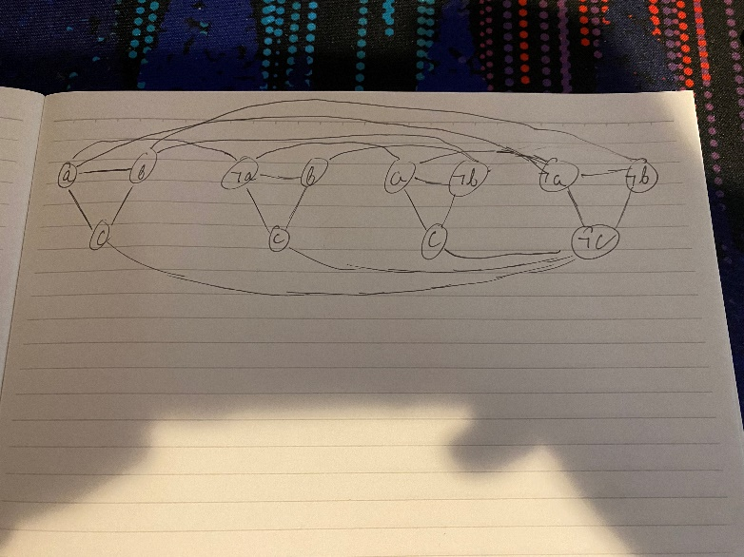
   2. Determine whether there exist a set of clauses such that no two clauses share a common variable assignment
   3. [A1, B2, C3]
3. 1. See cs412_np_independent_set.py